University of Michigan Dearborn

CIS 487 - Game Design I

**Where Does the Fox Go?**

Game Pitch Document

Cody Lovelace

Ingrid Camille Lagman

Jasmine Rabie

Jada Sardin

*Wednesday, November 3, 2021*

1. **Executive Summary**

1.1 Abstract of Game Story

*Where Does the Fox Go?* isa 2D side scroller game. The game story is that the player is a baby fox who got lost in the forest and needs to find its way back home to its mom. As the fox is trying to get home there are many obstacles in the way. These obstacles include branches, holes in the ground, puddles, snails, and hunters. Using ‘spacebar’ (jump), ‘a’ (left), and ‘d’ (right) the player will be able to navigate the baby fox to pass these obstacles and get home safely to their mom.

1. **Game Play Look and Feel**

2.1 Appearance

*Where Does the Fox Go?* utilizes classic pixel-art graphics that harken back to the time of the Gameboy Color. The beginning stages use a lighter color palette, setting a whimsical and charming overture for the game. As the narrative advances over levels, a darker color palette takes its place, setting a grim, isolating, and sobering tone, with a consistent visual transition happening throughout each stage. The further the player journeys through the levels of the forest, the aesthetic, visual tonality, and overall haunting nature trend heavier and aim to command intrigue and focus toward storyline completion for the player.

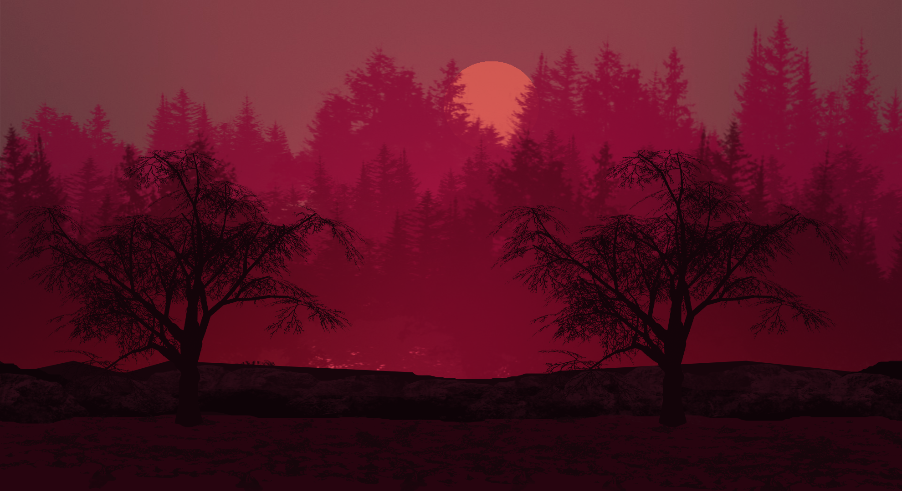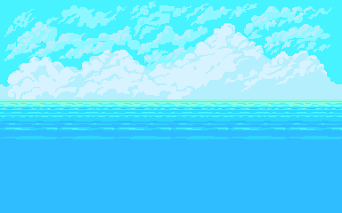

***Figure 1: (Dark, blood-red forests and relaxed cloudy seasides offer a contrasting aesthetic and tone for the game)***

The baby fox character’s sprite is most aptly described as a far-off cousin of Sega Genesis’ Sonic the Hedgehog, but with its colors and anatomical features far closer to its real-life animal counterpart. Assets throughout the environment - such as the trees, assorted flora and fauna, and earthly terrain - are all deliberately chosen as they appear to be objects that would naturally exist in the fox protagonist’s world.



***Figure 2: (Baby Fox sprite as compared to Sonic the Hedgehog)***

2.2 Player Roles and Actions

The player’s role is to navigate Baby Fox to get to their home and family. In order to navigate the fox, the player must use the ‘spacebar’, ‘a’, and ‘d’ keys on their keyboard to move the fox around the screen. The ‘spacebar’ key would be pressed to move the fox upward by jumping in the landscape. The ‘d’ key would be pressed to move the fox forward in the landscape. The ‘a’ key would be pressed to move the fox backwards in the landscape. The player must utilize the keys mentioned above to navigate or avoid obstacles in the landscape.

2.3 Strategies and Motivations

The game design could begin with the presumptuous idea that the average person is already familiar with video games in the side-scrolling and platformer genres. To deviate from that assumption, it was important to us that our game imbued distinctive motivations for the player and allowed for newbie and veteran players alike to flex their budding or existing strategic prowess learned from similar titles in these genres.

On the most simplistic level, the player aims to complete each stage by traversing from left to right, with the background, terrain, and obstacles scrolling across the playable environment according to input from the keyboard controls. Earlier levels subtly tutorialize fundamental platformer strategies, with a learn-by-doing teaching approach helping the player to differentiate between background and foreground objects.

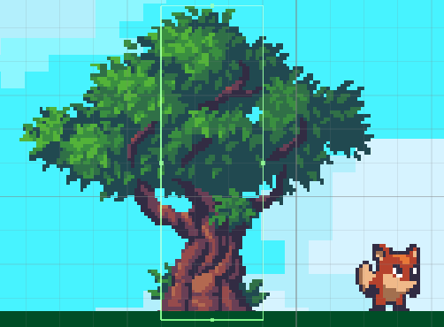

***Figure 3: (Tree object showing basic collider shape)***

Beginning levels reinforce learning by tying forward progression to an understanding of x-axis movement and how it can be combined with singular y-axis jumping motions to clear or climb obstacles. As levels are completed, new challenges begin to be deployed in the form of surprise pitfalls, rising and falling platforms, and vertical climbs. These obstacles test the player’s ability to combine familiar movement mechanics with precise timing to progress.

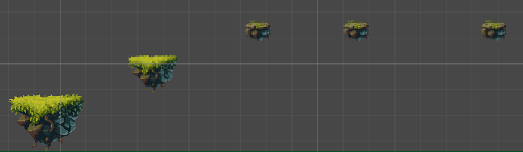

***Figure 3.1: (Early prototype view of more advanced floating platforms)***

Platforming and side-scrolling video games are inherently rewarding for those that enjoy progression-based mechanics and/or perfecting their mechanical skills to navigate obstacles requiring pinpoint accuracy and timing. While coasting on these baked-in motivations would be a simple (and rather mundane) design choice, our team decided upon a narrative that would invoke an emotional pathos and compel the player forward.

Beginning with a baby fox - the soon to be identified player character - being separated from its parents in a forest fire, the desire to see a family reunited touches upon themes of belonging vs. isolation, prolonged loneliness, and forced self-reliance through adversity. Initial foreshadowing through silhouettes and shadows implies a pursuer unknown to the baby fox, creating and building tension throughout gameplay. These elements capitalize upon the player’s desire to escape the forest, protect Baby Fox at all costs, and eventually reach a satisfying ending to see the fox family finally reunited.

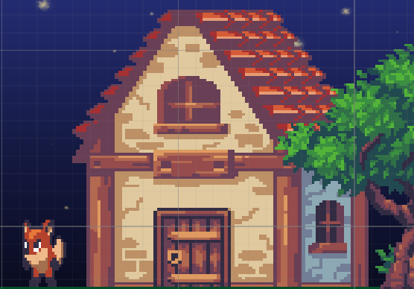

***Figure 4: (Mama Fox waiting in front of the family’s home)***

2.4 Level Summary / Story Progression

There will be three different levels for this game. The first level will have a morning time background to indicate that you are at the first level. The morning background will have blue skies and green forestry. The second level will be an afternoon background to indicate that you are at the second level. The second level will have a darker, greener background and more dense forestry. The third level will be a night background to indicate that you are at the third level. The third level will have a dark blue background and more dense forestry to indicate nighttime. The third level will be the most difficult with the player having to deal with more difficult jumps, the hunter, and the snail. The different levels will show a passing of time through the background to let the player know that as they progress through the different levels they are getting closer to the end of the game. Each level will be similar in types of obstacles, but as the player gets to the next level there will be more obstacles and the level will get more difficult. At the end of the third level, there will be a house and the mom fox to indicate to the player that they finished the game.

Each level gets Baby Fox closer to the goal of reuniting with their family, and while the sense of hope is gained from the character’s perspective, the player has an omnipotent view of a mounting danger in the form of hunters pursuing the fox in attempts to stop a happy ending. The story has a naturally occurring conflict in the form of player vs. environment, and as the story unfolds, player vs. enemy slowly steals the spotlight and warps the narrative in a similar way to Red Riding Hood’s simple walk in the woods to facing a deadly predator.



***Figure 5: (Early prototype juxtaposition of varying level backgrounds showing the transition of time)***

1. **Development Specification**

3.1 Hardware

***Table 1: Minimum Hardware Requirements Needed to Develop the Game***

To offer a glimpse at minimum hardware requirements to develop the game, official hardware specifications were pulled directly from Unity’s website.

| Minimum Hardware Requirements Needed to Develop the Game | |
| --- | --- |
| OS | Windows 7 (SP1+), Windows 10, and Windows 11, 64-bit versions only. |
| CPU | x86, x64 architecture with SSE2 instruction set support. |
| Graphics API | DX10, DX11, DX 12 compatible. |
| Additional Requirements | Hardware vendor officially supported drives. For development, IL2CPP scripting backend requires Visual Studio 2015 with C++ Tools component or later and Windows 10 SDK. |

***Table 2: Minimum Hardware Requirements Needed to Play the Game***

To gather information on minimum hardware requirements to play the game smoothly, specifications from comparable titles in the same genres and with similar visual stylings were collected. Titles investigated included Terraria, Toki Tori, Starbound, and PC ports of classic NES games like Super Mario Bros.

| Minimum Hardware Requirements Needed to Play the Game | |
| --- | --- |
| OS | Windows XP, Vista, 7, 8/8.1, 10 |
| Processor | 2.0 GHz |
| Memory | 200MB |
| Hard Disk Space | Hardware vendor officially supported drives. For development, IL2CPP scripting backend requires Visual Studio 2015 with C++ Tools component or later and Windows 10 SDK. |
| Video Card: | 128MB Video Memory, capable of Shader Model 2.0+ |
| DirectX® | 9.0c or Greater |

3.2 Software

The software used for this game is Unity. Assets used within Unity were pulled from the Unity Store, creative commons offerings from Itch.io, and as a stretch goal, sounds, and other assets created in-house by our design team.

3.3 Algorithm Style

*Where Does the Fox go?* is a 2D side scroller whereas the player moves the character around they can only go left or right (side to side). The whole game is played in the side view, the player will be able to go forward, backward, and jump to avoid obstacles and progress to the end of the game. The upward and downward movement employs a basic physics system that uses gravity as a way to cap jumping height and keep downward falling consistent.

Advanced obstacles have unique algorithms tied to them that can be varied to keep up a certain level of challenge for the player. Certain platforms when triggered by the player’s location (set to a certain x and y coordinate range to account for possible jumping maneuvers) will fall and require the player to think quickly. Other platforms alternate in a repetitive series of up-and-down or left-and-right motions which test the player’s ability to strategize future movements to traverse safely. Fire objects follow similar paths and must be avoided at all costs to prevent harm from falling to Baby Fox.

4.0 Media - User Interface Samples

*Where Does the Fox go?* plans to use a minimalist UI that is in line with retro games from the NES and Sega Genesis era. The game menu in the beginning is currently drafted with a dark forest background and menu buttons with bright text. As a low priority, late-stage item, the menu will likely contain animations like the baby fox sitting near a fire, star and moonlight, and other animals visiting the beginning menu.

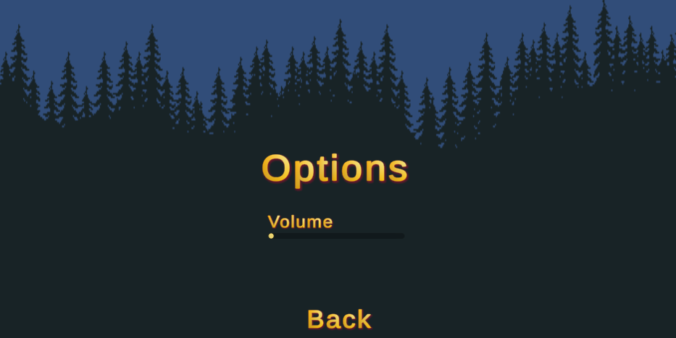

***Figure 6: (Opening game menu interface and initial options design)***

Upon implementing a UI hub into the main game, we plan to use UI Pack by Andel Rodis. Like the image below, an X icon will appear in the top right corner allowing the player to exit the game.

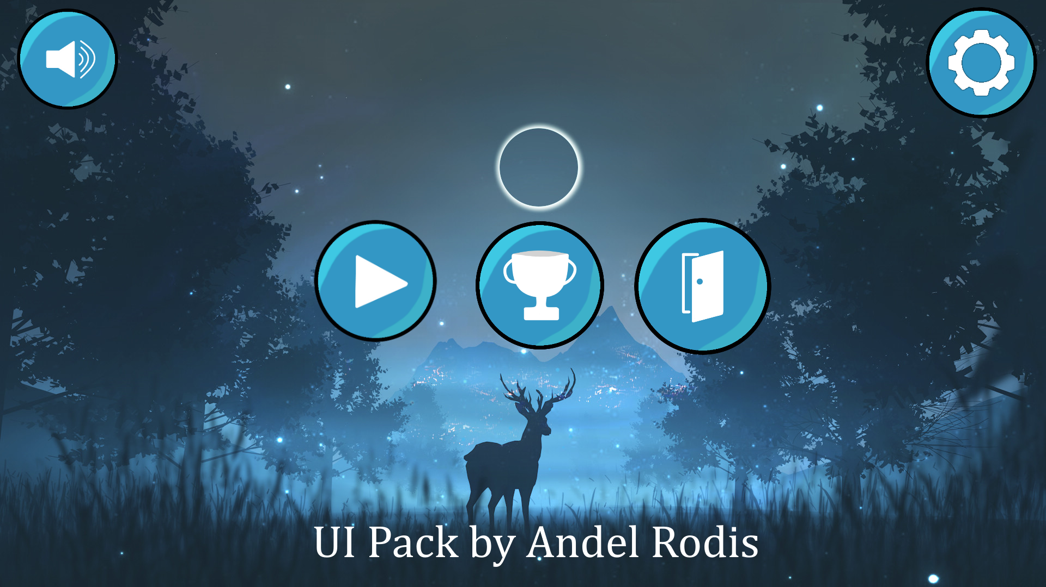

***Figure 6.1: (The asset UI Pack by Andel Rodis planned to be use for a clean, minimal UI look within the game)***

For additional reference, we have created a list of assets that will be used in various capacities within the game upon launch. Sorted between each category with brief descriptions of their intended use, this is a dynamic list for our reference and to shed light on the overall artistic direction.

**Assets**

* **Sound Effects**
  + **Footsteps on Leaves**
    - <https://assetstore.unity.com/packages/audio/sound-fx/foley/footsteps-leaves-175346>
  + **Footsteps on Gravel**
    - <https://assetstore.unity.com/packages/audio/sound-fx/foley/footsteps-gravel-175348>
  + **HALFTONE Sound Effects (Sounds for basic motions like jumping)**
    - <https://void1gaming.itch.io/halftone-sound-effects-pack-lite>
  + **Interface SFX Pack 1 (Sounds for when interacting with UI buttons and things)**
    - <https://obsydianx.itch.io/interface-sfx-pack-1>
  + **Nature Sound FX (This is everything we need for environmental ambience, especially the fire stuff IMO)**
    - <https://assetstore.unity.com/packages/audio/sound-fx/nature-sound-fx-180413>
* **Music**
  + **Medieval Fantasy RPG Music Pack (A few tracks appropriate for this game’s feel IMO)**
    - <https://masterofrevels.itch.io/medieval-fantasy-rpg-music-pack>
  + **You Don’t Need a Hero (Some more whimsical tracks, especially appropriate for earlier levels)**
    - <https://evilduckk.itch.io/sound-assets-for-your-adventure-game>
* **Backgrounds**
  + **The Dawn - Forest Background (perfect for fire scene?)**
    - <https://saurabhkgp.itch.io/the-dawn-parallax-background>
  + **Demon Woods Background (Cutscene of hunters pursuing fox?)**
    - <https://aethrall.itch.io/demon-woods-parallax-background>
  + **Pixel Art Parallax Forest (Solid forest background, potential for hunter cutscene as well)**
    - <https://macrune12.itch.io/parallax-forest>
* **Animations**
  + **Animated Fires** 
    - <https://stealthix.itch.io/animated-fires>
* **UI Interface**
  + **Simple UI Asset Pack (Perfect for minimal hud and the treasured exit button)**
    - <https://andelrodis.itch.io/simple-ui-asset-pack-57>
* **Obstacles, Tile Sets, and Set Dressing**
  + **Sunny Land (Fox, Terrain, Background)**
    - <https://assetstore.unity.com/packages/2d/characters/sunny-land-103349>
  + **GothicVania Cemetery (Spooky nighttime scary forest assets)**
    - <https://assetstore.unity.com/packages/2d/characters/gothicvania-cemetery-120509>
  + **Magic Cliffs Pixel Art (Trees, terrain, obstacles)**
    - <https://assetstore.unity.com/packages/2d/textures-materials/nature/magic-cliffs-pixel-art-environment-60458>
  + **Forest Lite Pixel Art (Trees, terrain, obstacles)**
    - <https://sanctumpixel.itch.io/forest-lite-pixel-art-tileset>
  + **Trees (Yes, they’re just trees)**
    - <https://jestan.itch.io/trees>
  + **Spring Blossom Trees (Like trees but kawaii)**
    - <https://elenetari.itch.io/spring-blossom-trees>